Group 2

Abbas Sajjad Hussein, Gia Huy Nguyen, Hla Myint Myat, Lamuel Tong Vargas Wong, Rashaun Bennett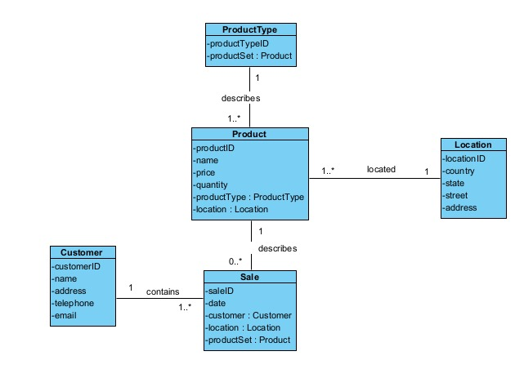

CreateCustomer

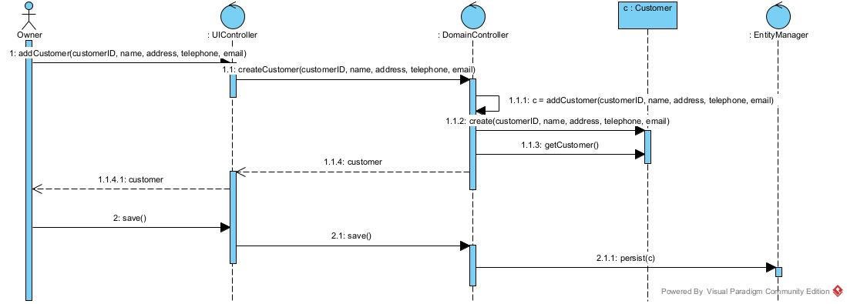

CreateSale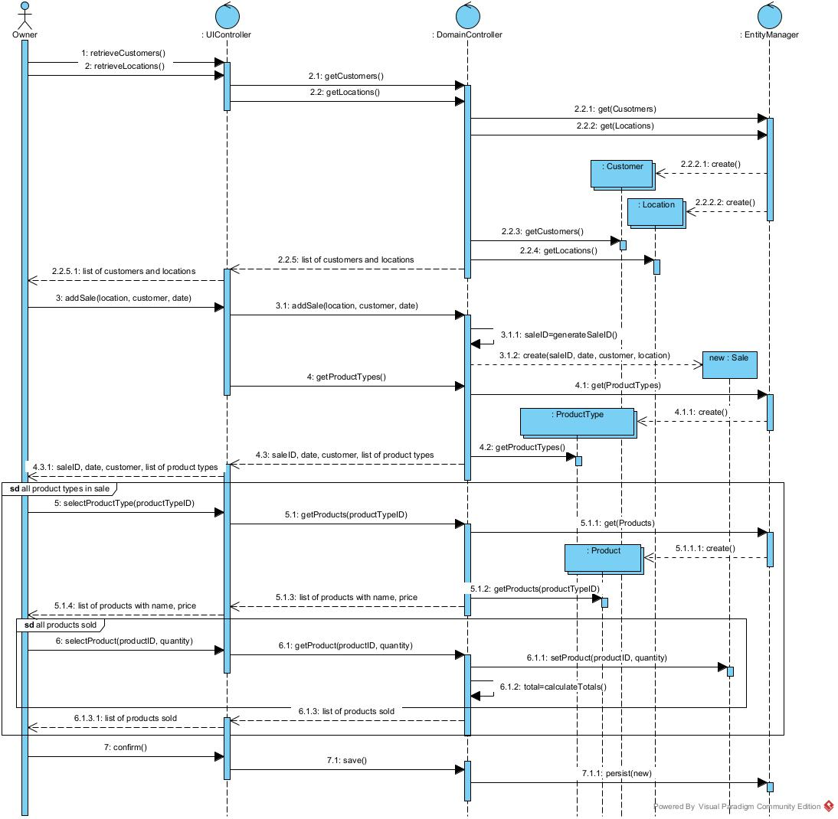

QueryPurchase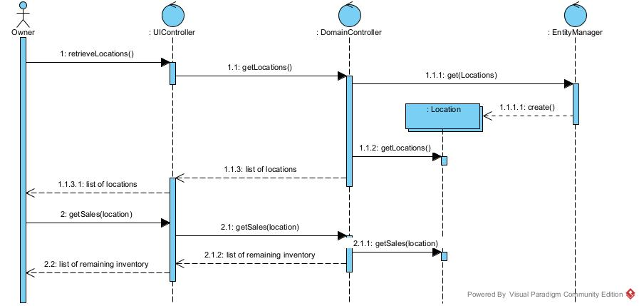

CreateInventoryAdjustment